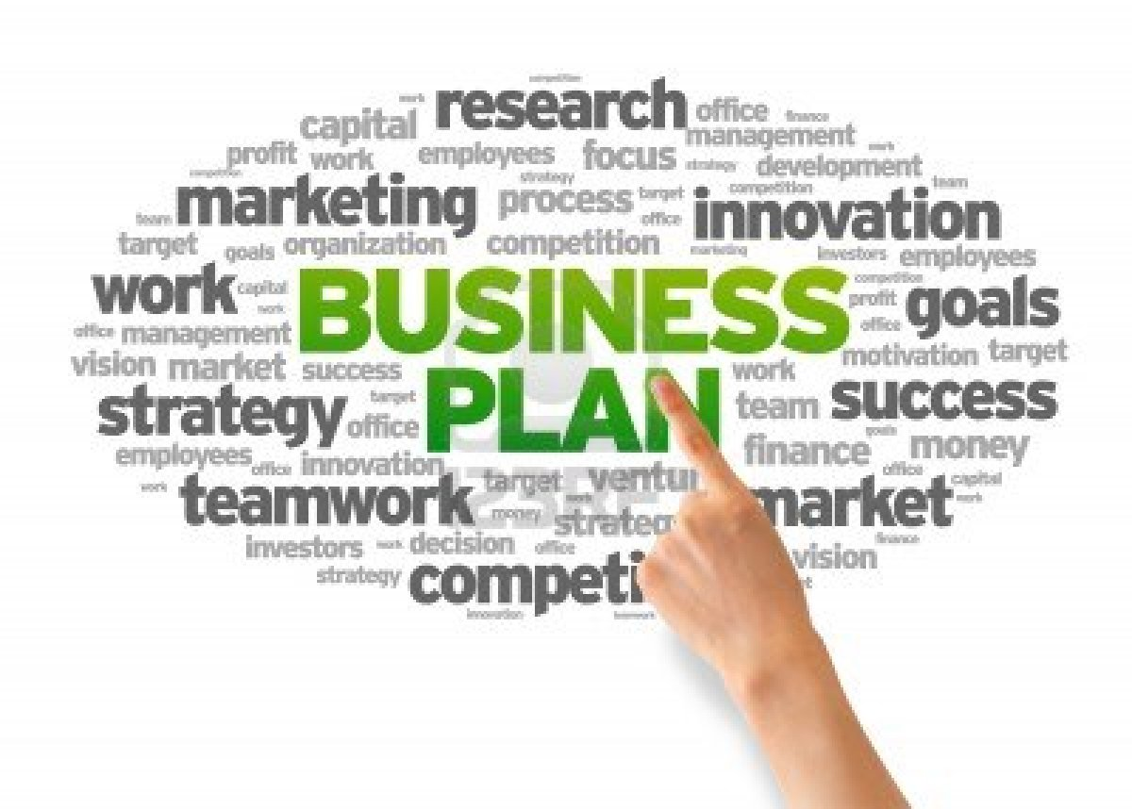

Made By : Zohaib Saleem

Adnan Khan

Salman Iqbal

Class : B.B.A VIII

Section : 2

Course : Entrepreneurship

Instructor : Syed Luqman Hakim

SARHAD PLASTIC INDUSTRIES (PVT.) LTD

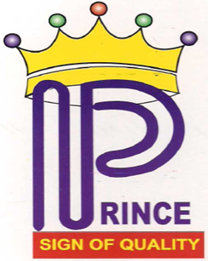



Plot # F-535, S.I.T.E., Karachi

Tel: 92-213-2564648-49, 2593137

Fax: 92-213-2586376

Website: http://sarhad plastic.com.pk

Email: [info@sarhadplastic.com.pk](mailto:info@sarhadplastic.com.pk)

22nd December 2015



**Table of Contents**

* Executive Summary
* Mission, Vision and Culture
* Company Description
* Opportunity Analysis and Research
* Marketing strategy and Plan
* Management and Operations
* Financial Analysis and projections
* Funding Request and Exit Strategy
* Appendices

**Executive Summary**

The assembling of UPVC channels through expulsion procedure is a practical business gave that it is worked with a decent business sharpness that includes having a careful information and experience of the item go, specialized prerequisites, operational methodology furthermore dealing with the occupations with the right sort of specialized labor. At the point when these components join with great and viable business advancement aptitudes, the business is relied upon to give significant benefits which are required to become throughout the years.

Channeling frameworks are the most vital components to cultivated living from individual life to industry exercises i.e., they are an essential base for urban situations. In Pakistan per capita PVC utilization in Pakistan was just 0.28 Kg contrasted with 7.75 Kg in USA and 5.11 Kg in Japan. This highlights the development capability of the PVC Pipe fabricating area in Pakistan.

As we all know that customers are the backbone of any business. The major consumers of these pipes can be divided into distinct market segments like water company, Gas Company; separate and independent residential zone (including residential real estate development and independent business community); the construction unit and intermediate business. We have tailored its marketing strategies to address the distinct characteristics of each market.

The firms who are the heaviest users of PVC pipe and tend to purchase the vast majority of this product in large quantities, at infrequent intervals we try to conduct  a series of informal interviews with decision makers in this segment to identify their key purchasing criteria.

We provide the product benefits and advantages which meet these key purchasing criteria. One of our most significant product benefits is the total installed cost savings it provides. Our product range benefits coincide with the market's most valued product criteria. Therefore, these attributes will be highlighted when targeting this market.

We will also use different marketing medium like news papers, news channels, trade journals, internet and further more to advertise our product in order to gain and attract customers.

Our goal is to furnish clients with quality included administrations, in term of solid conveyance and an extensive item extend. The owner of the company is Mr. Waqas, who is the experience holder in the field of UPVC pipe manufacturing and have the more knowledge to give business a bright future.

A UPVC pipes manufacturing unit needs a capital investment estimated at Rs. 15,691,200 for construction and purchasing machinery & equipment. In addition to this, a sum of Rs. 2,485,243 is required as working capital, which should be used for purchasing raw material and other inputs. The project has an IRR, Payback and NPV of 47%, 3.56 years and Rs. 35,650,548.

We have also developed the exit strategy if the business got failure. We will sell all the equipment and other valuable assets of the company in order to give back the amount of investors which we will raise as the investment. If any uncertainty happens, then don’t worry we have the insurance policy for all the valuable equipment and assets.

**Mission, Vision and Culture**

Mission

A mission statement is a short sentence or paragraph used by a company to explain, in simple and concise terms, its purposes for being.

“The mission of our company is to operate in the Pakistan’s PVC Pipe Manufacturing Industry to cater the needs of its customer related to PVC pipe throughout the country by using its advance technology and valuable human capital for rapid growth and to promote friendly and healthy environment because company believes that our customers and employees are our biggest strength”.

Vision

A vision statement is a company's road map, indicating both what the company wants to become and guiding transformational initiatives by setting a defined direction for the company's growth.

“The vision of the company is to develop a robust foundation of Pipe manufacturing Company, with a well respected and a reputed brand, using innovative ways of doing businesses in alignment with best business and our practice a ZERO HARM CHATER”.

Culture

Organizational culture is a system of shared assumptions, values, and beliefs, which governs how people behave in organizations. These shared values have a strong influence on the people in the organization and dictate how they dress, act, and perform their jobs.

The culture of our company is different from all others. It includes all the people from different countries, communities and societies and also with the plenty of skills related to UPVC Pipe manufacturing experience. All the people in our organization have equal rights and opportunities and also have the equal chance to grow upward in future. All people are also involved in decision making and also have the rights to discuss their ideas in front of all the members. All the people act as a family in our organization and enjoy the friendly and healthy working environment with a plenty of benefits in term of promotions, bonuses and increments etc.

**Company Description**

The type of our industry is manufacturing industry which manufactures PVC Pipes named as Prince UPVC Pipes for its valuable customers which is operating in Pakistan’s PVC Pipe Manufacturing Industry.

Strategic advantages mean the specific characteristics your company occupies as compared to your competitors. The strategic advantages of our company includes highly skilled and experience employees, advance technology, strong relationship with its supplier, strong database for inventory controlling and more efficient and effective customer relationship database for providing ease to its customers. The company has also the facility of online order and purchase of pipes. We will also stretch our business to global boundaries which will be an extra strategic advantage for the company.

The type of our company or business is corporation and will be listed in KSE 100. The company will fulfill all the rules and regulations made by the Ministry of industries and production, government of Pakistan related to tax, liabilities and so on.

Our company is located in the Sindh Industrial Trading Estate (S.I.T.E) Karachi. The area on which our company locates is 4 acres and has the ideal location which provides more ease to customers to reach easily by covering a short milestone.

The ownership structure shows the personnel hierarchy of an organization. The ownership structure of our company is very simple but consists of very experienced members. The ownership structure of our company is shown in the below diagram:

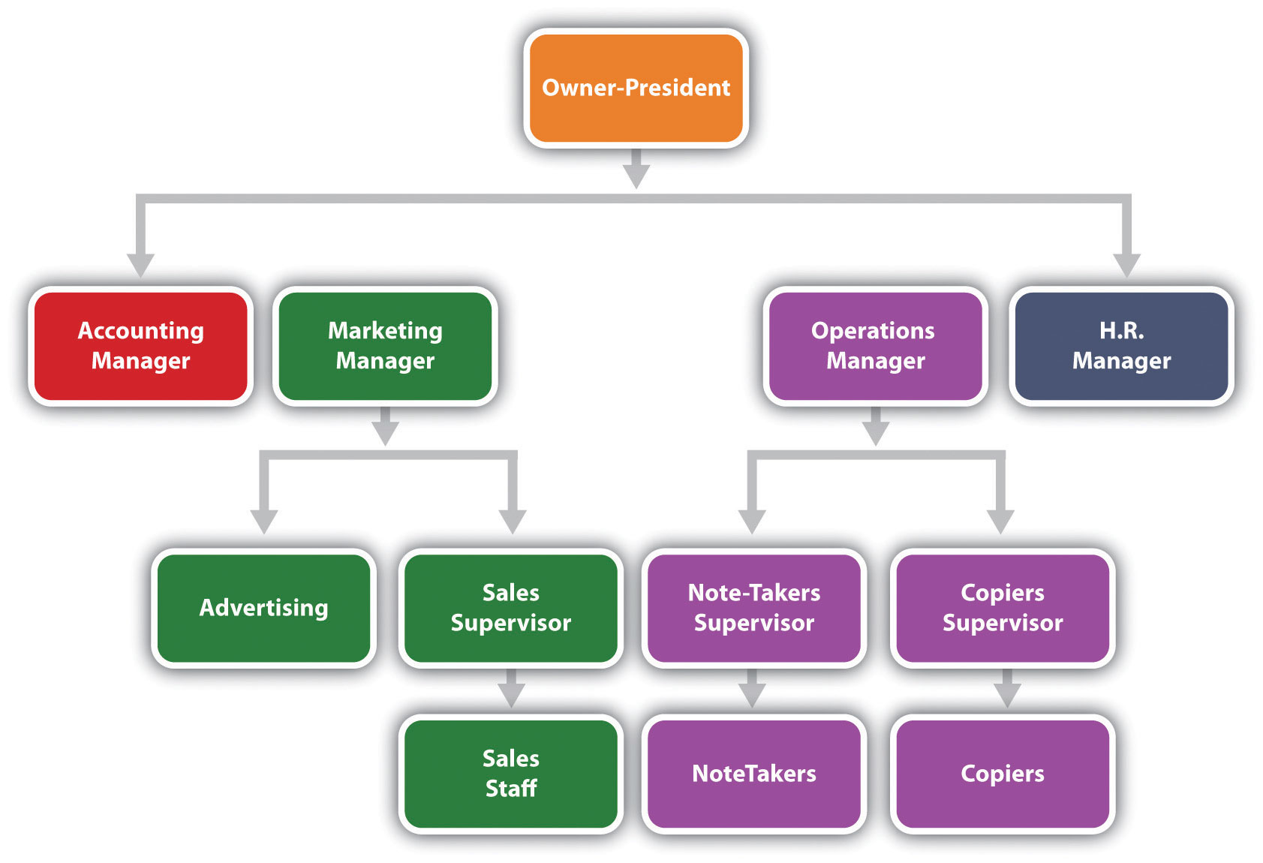

The above diagram is showing the hierarchy of our company. The hierarchy consists of important personnel’s like president, accounting manager, marketing manager, operations manager and H.R. manager. Marketing manager deals with the advertisement of the products. Sales supervisor also work in the guidance of marketing manager. Sales staff of the company works in the guidance of sales supervisor. The operation manager will supervise note-taker supervisor and copier’s supervisor. The note taker will work under the supervision of note-taker supervisor and copiers will work under the guidance of copier’s supervisors.

**Opportunity Analysis and Research**

According to Industry sources the PVC pipe manufacturing industry has presence in all major industrial cities of Pakistan (i.e. Karachi, Multan, Burewala, Lahore, Sialkot, Narrowal, Faisalabad, Gujranwala, Gujrat, Jhelum, Rawalpindi & Peshawar) which consists of around 400 manufacturing units and production of 180,000 tons per annum. The main companies involve in the manufacturing of PVC piep are Pak Arab, Adamjee Pipes, Galco and so on.

As we all realize that clients are the foundation of any business. The real customers of these channels can be partitioned into particular business sector fragments like water organization, Gas Company; separate and autonomous private zone (counting private land improvement and free business group); the development unit and middle business. We have customized its advertising techniques to address the unmistakable qualities of every business sector.

We have done the SWOT analysis in order to find out the important aspects of the internal and external environment which is given below:

Strengths

* Presence of pipes manufacturing cluster in Pakistan.
* The raw material supplier (Engro Asahi) assists in different issues relating to pipe production.
* The local machine manufacturers are present, and also assist the manufacturing units in setting up new lines.
* Cooperation exists between the local machinery suppliers and the small manufacturing units.
* Existence of basic knowledge and technology involved in manufacturing of UPVC pipes.
* Availability of basic infrastructure/network • Presence of few recognized brands from top-end manufacturers.

Weaknesses

* Volatility of raw material prices.
* Constants break down in local made machines or obsolete machines and irregular supplies of electricity and water etc leading to high level of wastage.
* Unchecked use of scrap material in pipes production which leads to inferior and hazardous pipes.
* Extreme price pressures and low margins at all levels of market leading to continuous price wars among stakeholders to catch new customers.
* Lack of design guides and standards.
* Products only manufactured by large and medium units are according to safety and quality standards.
* There is no pressure or demand from consumers to uplift and maintain quality of products
* Unskilled labor and machine operators.
* No technical expert in the field of PVC extrusion to help with machine fabrication.
* No research and development in areas of development of competitive technologies. Understanding of new technology is low.
* Supply of products is limited to small local market with limited purchasing power, leading to manufacturing below full capacity.

Opportunities

* Diversified product range.
* Strong future domestic market demand for quality products.
* Scope of increased penetration in other sectors as a result of awareness about its advantages and different uses.
* Possibility of market penetration (export) to neighboring countries.
* Increasing interest of foreign and local investors benchmarking of market leaders for small units to up-grade their technology base.
* Establishment of an information sharing/dissemination mechanism among UPVC industry to keep them updated on international trends.

Threats

* The market of UPVC remains under pressure from high energy and feed stock costs.
* Irregular availability of high quality raw materials especially before a price hike.
* Pakistan products do not have a good quality image.
* Increasing availability of international brands in local market – aggressive competition especially from China, Malaysia, Iran, Indonesia and India.
* Environmental legislation and other restrictions concerning the proper way to recycle and dispose PVC products.
* No training institutes at national level to guide the industry towards new technology and product line.

We have also done the competitive analysis between Pak Arab, Dadex and Sarhad Plastic and find out the following information:

|  |  |  |  |  |  |  |  |
| --- | --- | --- | --- | --- | --- | --- | --- |
|  |  | **PAK ARAB** | | **SARHAD PLASTIC** | | **DADEX** | |
|  | **Weight** | **Rating** | **Score** | **Rating** | **Score** | **Rating** | **Score** |
| Critical Success Factors |  |  |  |  |  |  |  |
|  |  |  |  |  |  |  |  |
| Technology | 0.1 | 3 | 0.3 | 3 | 0.3 | 4 | 0.4 |
| Best Rates | 0.3 | 4 | 1.2 | 2 | 0.6 | 3 | 0.9 |
| Product Innovation | 0.2 | 3 | 0.6 | 2 | 0.4 | 2 | 0.4 |
| Quality | 0.2 | 3 | 0.6 | 2 | 0.4 | 4 | 0.8 |
| Brand Image (Recognition) | 0.1 | 2 | 0.2 | 2 | 0.2 | 1 | 0.1 |
| Size Of The Company | 0.1 | 3 | 0.3 | 2 | 0.2 | 2 | 0.2 |
|  |  |  |  |  |  |  |  |
| Total | **1** |  | **3.2** |  | **2.1** |  | **2.8** |

**Interpretation**

Table indicates that:

* DADEX is strongest in technology than PAK ARAB & SARHAD PLASTIC
* PAK ARAB is strongest in rates
* PAK ARAB offers best product innovation in market
* DADEX service quality is better than PAK ARAB & SARHAD PLASTIC
* SARHAD PLASTIC & PAK ARAB both have well known name in the market
* PAK ARAB is huge in size than SARHAD PLASTIC and DADEX

Numbers indicates that PAK ARAB on the whole is best between SARHAD PLASTIC and DADEX.

**Marketing Strategy and Plan**

The market strategy and plan of our company is based on the five important factors which are discussed below:

Products: PVC pipes in Pakistan are covering almost all the sectors of Pakistan especially construction industry. So our product will offer many characteristics that you have never heard before. The quality, price and delivery services will be of A-1 grade because we value our customers and want to build strong brand image in the mind of customers that will never erased. The Price UPVC Pipes will be available in 25mm, 32mm and 40mm sizes. Our pipes will give you the best benefit in return of your values you will pay for it. We will also planning to introduce pipes in different colors and design that will look more attractive. The unit we use for selling our pipes will be RFT (Running feet) or RMT (Running Meter).

Pricing: Our Company will use the price strategy that will be lower than our competitors but the quality of our products will be very reliable as compared to others. We want to earn profit in our business but not extraordinary. We want to attract the customers by giving them high quality products but in low prices.

Promotion: We will use the different medium to promote our products and to create a positive and good image in the minds of customers. We will advertise our products on news channels, magazines, journal article, and websites and also uses signboards, panaflex, and so on. We will also attract customers by mailing them on different social websites face book, twitter etc.

Place: Our company will try to capture customers in the whole city i.e. Karachi. Then we will divide the customers in two parts. The first one is those who are the larger firms and organizations who will purchase large amount of pipes and they are entertained directly through the company by the experience personnel. The second are those which include individual’s customers and retailers etc. we will open a number of outlets of our company in the main markets near to our competitors and entertain the individual customers and retailers through outlets.

Philanthropy: Our Company will be environment friendly and also play its role in social responsibilities. We will also contribute a fixed percent of profit to different communities as a charity for the well being of the people. We will also make necessary arrangements for the smoke omitting from manufacturing plant in order to protect our environment. We will also try our employees to get engaged in social work. We will also offer special discounts on our products for non-profit organizations like small communities, old age homes etc.

**Management and Operations**

Our management team combines the experiences of executives with extensive backgrounds in managing and developing successful businesses within the pipe manufacturing industries. We have one senior executive and are in the process of hiring a support staff, who will be involved in managing operations, marketing, and manufacturing of the Prince UPVC pipes. All the employees who will be hired are based on their knowledge and experienced within the PVC pipes manufacturing industry. We will also give chances to fresh people to come forward and show their skills.

The company will also develop R & D department who will find out the important information related to technology, innovations, ideas etc. we will also hire the personnel who do this by surveys and getting feedbacks through questionnaire, focus groups and so on.

Our company is located in the Sindh Industrial Trading Estate (S.I.T.E) Karachi. The area on which our company locates is 4 acres and has the ideal location with all the facilities including transportation, near to customers and competitors etc which provides a strategic advantage to the company. All the necessary equipment like machinery, office furniture’s and other necessary items will be equipped with latest technology and state of the art features.

The company will equip PVC pipe manufacturing machine imported from Taiwan which will meet all our requirements related to PVC pipes. The machine is made up of latest technology for effective and efficient product. The diagram of machine is given below:

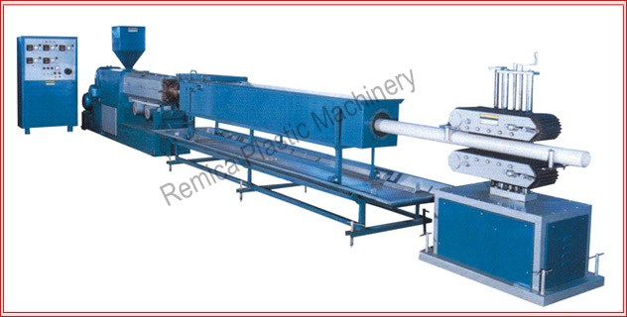

The basic raw materials for PVC are derived from salt and oil. Chlorine is manufactured by the electrolysis of sodium chloride, salt. The electrolysis of salt water produces chlorine. The chlorine is then combined with ethylene that has been obtained from oil. The resulting element is ethylene dichloride, which is converted at very high temperatures to vinyl chloride monomer. These monomer molecules are polymerized forming polyvinyl chloride resin.

The inventory we will maintain in order to satisfying our customers’ needs is 300 RFT and the production of the pipes based on the orders from the customers but we will initially produce 210 meter per day and try to increase this capacity to 300 meter per day in the next 6 months.

Our company is very much subjected to quality concern. Our company wants to deliver high quality products for our valuable customers so for this assurance we will develop quality control department who will focus on the quality of pipes to make sure that the customers are getting a right quality product against the cost they are paying for the products.

**Financial Analysis and Projections**

The start-up capital requirement of the firm is given below:

|  |  |  |
| --- | --- | --- |
| **Capital Investment** |  | **In Rs.** |
| Land |  | 3,680,000 |
| Building/Infrastructure |  | 7,580,000 |
| Machinery & Equipment |  | 3,819,200 |
| Furniture and Fixtures |  | 212,000 |
| Office Equipment |  | 95,000 |
| Pre-operating Cost |  | 305,000 |
| **Total Capital Cost** |  | **15,691,200** |
|  |  |  |
| **Working Capital** |  | **In Rs.** |
| Equipment Spare part Inventory |  | - |
| Raw Material Inventory |  | 1,939,950 |
| Cash |  | 545,293 |
| **Total Working Capital** |  | **2,485,243** |
|  |  |  |
| **Total Investment** |  | **18,176,443** |
|  |  |  |
| **Initial Financing** |  | **In Rs.** |
| Debt | 50% | 9,088,222 |
| Equity | 50% | 9,088,222 |
|  |  |  |
|  | **Equity** | **Project** |
| **IRR** | 61% | 47% |
| **Payback Period (years)** | 3.28 | 3.56 |
| **Net Present Value** | 36,938,863 | 35,650,548 |

We have projected the cash flow for the 5 years and found the following information given in the below table:

|  |  |  |  |  |  |  |
| --- | --- | --- | --- | --- | --- | --- |
| **Projected Cash Flow Statement** | | | | | | |
|  | **Year 0** | **Year 1** | **Year 2** | **Year 3** | **Year 4** | **Year 5** |
| Operating Activities | (1,939,950) | 1,746,605 | 2,517,171 | 5,529,060 | 9,316,658 | 14,597,604 |
| Financing Activities | 18,176,443 | - | (1,498,672) | (1,756,849) | (2,059,503) | (2,414,295) |
| Investing Activities | (15,691,200) | - | - | - | - | - |
| **Net Cash Flow** | **545,293** | **1,746,605** | **1,018,499** | **3,772,211** | **7,257,155** | **12,183,309** |

We have also projected the income statement for the next 5 years and found the following information:

|  |  |  |  |  |  |
| --- | --- | --- | --- | --- | --- |
| **Projected Income Statement** | | | | | |
|  | **Year 1** | **Year 2** | **Year 3** | **Year 4** | **Year 5** |
| Gross Profit | 4,892,346 | 7,861,920 | 11,809,476 | 16,910,318 | 23,364,892 |
| Operating Expenses | 2,509,515 | 2,816,162 | 3,167,574 | 3,569,638 | 4,028,970 |
| Operating Income | 2,382,831 | 5,045,758 | 8,641,902 | 13,340,680 | 19,335,922 |
| Net Income | 1,861,600 | 2,920,854 | 5,937,351 | 9,977,947 | 15,250,784 |

We have also projected the income statement for the next 5 years and found the following information:

|  |  |  |  |  |  |  |
| --- | --- | --- | --- | --- | --- | --- |
| **Projected Balance Sheet** | | | | | | |
|  | **Year 0** | **Year 1** | **Year 2** | **Year 3** | **Year 4** | **Year 5** |
| Total Current Assets | 2,485,244 | 6,617,683 | 10,464,969 | 16,229,518 | 25,804,867 | 40,361,670 |
| Total Fixed Assets | 15,386,200 | 14,594,580 | 13,802,960 | 13,011,340 | 12,219,720 | 11,428,100 |
| Total Current Liabilities | - | 1,418,219 | 2,990,703 | 3,722,129 | 4,526,414 | 5,394,108 |
| Total Long Term Liabilities | 9,088,222 | 9,088,222 | 7,589,550 | 5,832,701 | 3,773,198 | 1,358,903 |
| Total Equity | 9,088,222 | 10,949,822 | 13,870,676 | 19,808,027 | 29,785,974 | 45,036,758 |

We have also found out the Break-Even Analysis. We have the following 3 types of pipes and the related information is given in the below table:

|  |  |  |  |  |
| --- | --- | --- | --- | --- |
| **Break-Even Analysis** | | | | |
| **Size** | **Prices (Rs.)** | **Variable Cost (Rs.)** | **Fixed Cost (Rs.)** | **Break-Even Analysis** |
| 25mm | 270 | 120 | 10000 | 37 |
| 32mm | 432 | 190 | 10000 | 23 |
| 40mm | 729 | 425 | 10000 | 14 |

We would need to sell the above mentioned units per month in order to reach break-even points.

We have also found out the different and important ratios and projected the situation of next five years which are showing the position of company in the next five years. The table is given below:

|  |  |  |  |  |  |  |
| --- | --- | --- | --- | --- | --- | --- |
| **Ratios Analysis** | | | | | | |
| **Ratios** | **Year 1** | **Year 2** | **Year 3** | **Year 4** | **Year 5** | **Units** |
| Current Ratio | 4.67 | 3.5 | 4.36 | 5.7 | 7.48 | times |
| Quick Ratio | 2.7 | 2.3 | 3.15 | 4.47 | 6.28 | times |
| Net Profit Margin | 6.03 | 7.17 | 11.36 | 15.18 | 18.75 | % |
| Return on Assets | 8.68 | 11.94 | 20.22 | 26.2 | 29.45 | % |
| Return on Equity | 17 | 21.06 | 29.97 | 33.5 | 33.86 | % |
| Total Asset Turnover | 1.44 | 1.66 | 1.78 | 1.72 | 1.57 | times |
| Inventory Turnover | 11.08 | 11.39 | 11.62 | 11.81 | 12.54 | times |
| Debt Equity | 0.96 | 0.76 | 0.48 | 0.28 | 0.15 | times |

The above table is showing a very good position and growth aspects in the next 5 years.

**Funding Request and Exit Strategy**

We hope that you liked our business plan but this all things are incomplete without your support. In order to achieve this growth, the Company is looking to secure funding through debt from bank and also through equity in order to start the business. The Company is seeking Rs. 18,176,443 as the starting capital. The company will use this investment in terms of payroll, marketing, equipments, raw material and in operational activities.

As we all know that business are also associated with many risks and barriers which can become hurdle in the growth of the business. Following are the risks and barriers we have found which can become hurdle in our company’s growth:

Interest Rate: The variations in the interest rates can affect the growth of the company and can disturb the ability of debt paying to the banks.

Uncertainty Risk: The uncertainties like floods, earthquake etc can also become hurdle in the way of company’s growth.

Exchange Rate Risk: The variations in the exchange rates can affect the growth of the company.

Changes in Raw Material Prices: The changes in the prices of raw materials can also disturb our inventory and production system.

Shortage of Gas and Water Supply: The shortage in the supply of gas, water and electricity can also disturb our production system.

Changes in Oil Prices: The variations in the oil prices can affect the growth of the company because oil is also used in the machinery for the production of pipes.

Transportation Risk: The current un‐organized logistics system poses a serious threat to the company. This may result in temporary disruption of supplies to customers and retail outlets thereby affecting the profitability of the company.

Changes in Government Policies: The changes in the rules and regulations by the government for taxes, imports, exports etc can affect the company badly.

Inflation Risk: The Company is open to inflation risk like that of the whole economy. Inflation risk may be translated to erosion of values vis‐à‐vis foreign currency exchange fluctuations. There is a possibility that the value of assets or income of the Company may decline as increasing inflation shrinks the purchasing power of the Pakistan Rupee.

So these are the some risk and barriers which we have mentioned and discussed above. We will try to reduced or eliminate all these risks and barriers in order to give a bright future to the company.

As we all know that success is not guaranteed in any business may be you will get success or get failed so we have also considered the negative side of our business. If it gets fails then we will return back the all the investment of investors and also debt by selling out company’s valuable assets like machinery, building, land, accessories and so on. We will also think of another option in case of failure. We will think of merger or acquisition with other companies in order to return back the liabilities.

Win or lose is the part of the game but we will try our best to give the company best and bright future by giving our time, expertise and skills. We want to make our company one of the most popular and famous company of the Pakistan and also of the globe in the next 10 years and for this we will put our extra ordinary efforts in the company to make it profitable.

**Appendices**

Detailed Financial Projections

|  |  |  |  |  |  |  |  |
| --- | --- | --- | --- | --- | --- | --- | --- |
| **Projected Balance Sheet** | | | | | | | |
|  | **Year 0** | | **Year 1** | **Year 2** | **Year 3** | **Year 4** | **Year 5** |
| **Asset** | | | | | | | |
| **Current asset** | | | | | | | |
| cash & Bank | 545,293 | | 2,291,898 | 3,310,397 | 7,082,608 | 14,339,764 | 26,523,073 |
| Account receivable | - | | 1,542,857 | 3,579,429 | 4,650,171 | 5,899,269 | 7,351,683 |
| Finished goods inventory | - | | 216,373 | 273,913 | 337,188 | 406,692 | 482,962 |
| Raw material inventory | 1,939,950 | | 2,566,554 | 3,301,231 | 4,159,551 | 5,159,143 | 6,003,952 |
| **Total Current Asset** | **2,485,244** | | **661,683** | **1,046,469** | **16,229,518** | **25,804,867** | **4,036,160** |
| **Fixed Asset** | | | | | | | |
| Land | 3,680,000 | | 3,680,000 | 3,680,000 | 3,680,000 | 3,680,000 | 3,680,000 |
| Building/Infrastructure | 7,580,000 | | 7,201,000 | 6,822,000 | 6,443,000 | 6,064,000 | 5,685,000 |
| Machinery & Equipment | 3,819,200 | | 3,437,280 | 3,055,360 | 2,673,440 | 2,291,520 | 1,909,600 |
| Furniture & Furniture | 212,000 | | 190,800 | 169,600 | 148,400 | 127,200 | 106,000 |
| Office Equipment | 95,000 | | 85,500 | 76,000 | 66,500 | 57,000 | 47,500 |
| **Total Fixed Asset** | **15,386,200** | | **14,594,580** | **13,802,960** | **13,011,340** | **12,219,720** | **11,428,100** |
| **Intangible Asset** | | | | | | | |
| pre-operating costs | 305,000 | | 244,000 | 183,000 | 122,000 | 61,000 | - |
| Total Intangible Asset | 305,000 | | 244,000 | 183,000 | 122,000 | 61,000 | - |
| **Total Asset** | **18,176,443** | | **21,456,263** | **24,450,929** | **2,936,285** | **38,085,586** | **51,789,769** |
| Other Liabilities |  | |  |  |  |  |  |
| Long term debt | 9,088,222 | | 9,088,222 | 7,589,550 | 5,832,701 | 3,773,198 | 1,358,903 |
| **Total Long Term Liabilities** | **9,088,222** | | **9,088,222** | **7,589,550** | **5,832,701** | **3,773,198** | **1,358,903** |
| **Shareholder Equity** | | | | | | | |
| Paid-up capital | 9,088,222 | 9,088,222 | | 9,088,222 | 9,088,222 | 9,088,222 | 9,088,222 |
| Retained earning | - | 1,861,600 | | 4,782,454 | 10,719,806 | 20,697,752 | 35,948,539 |
| Total Equity | 9,088,222 | 10,949,822 | | 13,870,676 | 19,808,028 | 29,785,974 | 45,036,761 |
| **Total Capital And Liabilities** | **18,176,443** | **21,456,263** | | **24,450,929** | **29,362,857** | **38,085,586** | **51,789,769** |

|  |  |  |  |  |  |
| --- | --- | --- | --- | --- | --- |
| **Projected Income Statement** | | | | | |
|  | **Year 1** | **Year 2** | **Year 3** | **Year 4** | **Year 5** |
| Revenue | 308571543 | 40731429 | 52272000 | 65713371 | 81320297 |
| Cost of goods sold | 25,964,796 | 32,869,509 | 40,462,542 | 48,803,053 | 57,995,405 |
| **Gross Profit** | **4892346** | **7861920** | **11809476** | **16910318** | **23364892** |
| **General administration & selling expenses** | | | | | |
| Administration expenses | 552000 | 605744 | 664720 | 729438 | 800457 |
| Utilities expense | 401695 | 441864 | 486051 | 534656 | 588121 |
| Office expenses (stationary, etc.) | 55200 | 60574 | 66472 | 72944 | 80046 |
| Promotional expense | 617143 | 814629 | 1045440 | 1314267 | 1626406 |
| Professional fees (legal, audit, etc.) | 30857 | 40731 | 52272 | 65713 | 81320 |
| Depreciation expense | 791620 | 791620 | 791620 | 791620 | 791620 |
| Amortization expense | 61000 | 61000 | 61000 | 61000 | 61000 |
| **Subtotal** | **2509515** | **2816162** | **3167574** | **24569638** | **4028970** |
| **Operating Income** | **2382832** | **5045758** | **8641901** | **13340680** | **19335922** |
| Other income | 99302 | 196080 | 363755 | 749783 | 1430199 |
| Earnings Before Interest Tax | 2482133 | 5241838 | 9005675 | 14090463 | 20766121 |
| Interest Expense | 1347366 | 1089188 | 786534 | 431742 | 64115 |
| Earnings Before Tax | 2482133 | 5241838 | 9005657 | 14090463 | 20766121 |
| Taxable earning for the year | 2482133 | 3894472 | 7916468 | 13303929 | 20334379 |
| Tax | 620533 | 973618 | 1979117 | 3325982 | 5083595 |
| **Net Profit/(Loss) After Tax** | **1861600** | **2920854** | **5937351** | **9977947** | **15250784** |

|  |  |  |  |  |
| --- | --- | --- | --- | --- |
| **Projected Cash Flow Statement In Rs.** | | | | |
|  | **Year 0** | **Year 1** | **Year 2** | **Year 3** |
| **Operating activities** | | | | |
| Net Profit | - | 1,861,600 | 2,920,854 | 5,937,351 |
| Add: depreciation expense | - | 791,620 | 791,620 | 791,620 |
| amortization expense | 61,000 | 61,000 | 61,000 | 61,000 |
| Deferred income tax | - | - | - | - |
| Account Receivable |  | (1,542,857) | (2,036,571) | (1,070,743) |
| Finished goods inventory |  | (216,373) | (57,539) | (63,275) |
| Raw material inventory |  | (626,604) | (734,676) | (858,320) |
| Account payable |  | 1,418,219 | 1,572,483 | 731,426 |
| **Cash Provided by operation** | **(1,939,950)** | **1,746,605** | **2,517,171** | **5,529,060** |
| **Financing activities** | | | | |
| Change In long term debt | 9088222 | - | (1,498,672) | (1,756,849) |
| Issuance of shares | 9088222 | - | - | - |
| **Cash provided by/(used for) financing activities** | **18176443** | **-** | **(1,498,672)** | **(1,756,849)** |
| **Investing activities** | | | | |
| Capital Expenditure | (15,691,200) | - | - | - |
| **Cash provided by/(used for) Investing activities** | (15,691,200) | - | - | - |
| **Net cash** | **545,293** | **1,746,605** | **1,018,499** | **3,772,211** |

Product Pictures

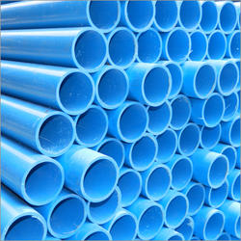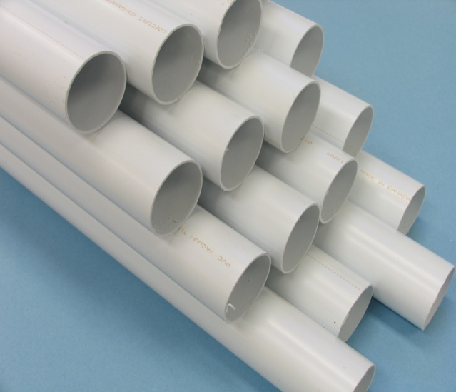

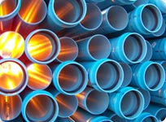

Advertising and Promotional Samples

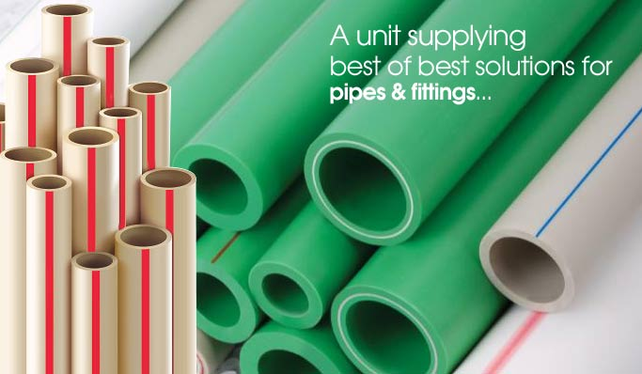

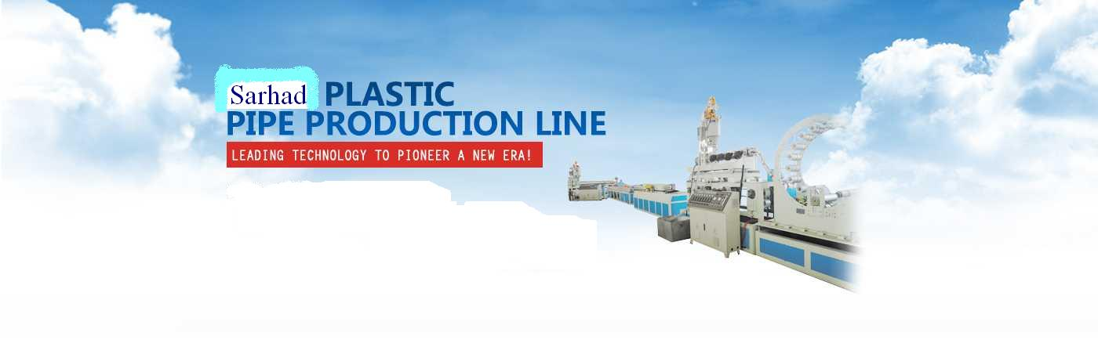

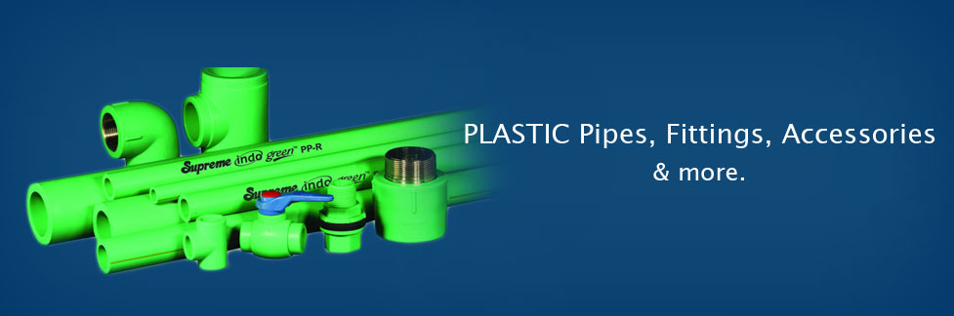

Company/Brand Logo

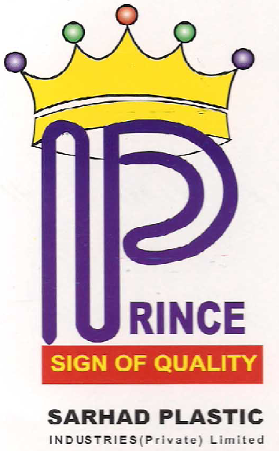

Certificates

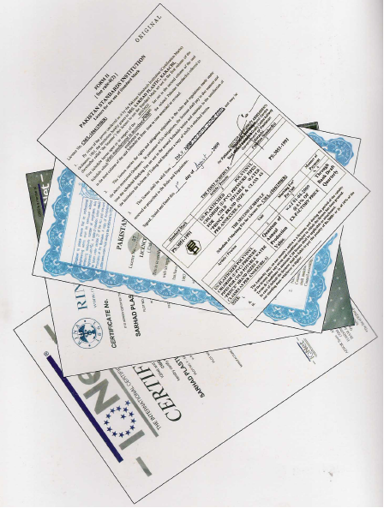

Raw Materials

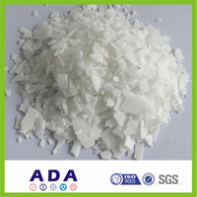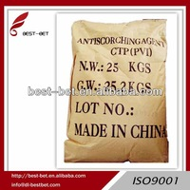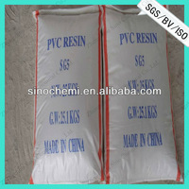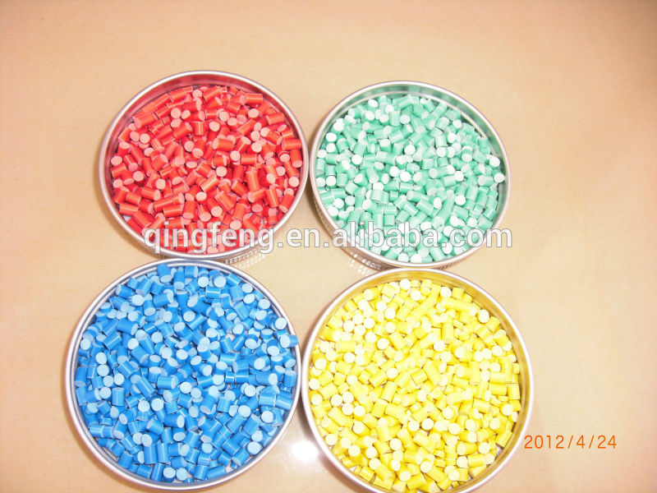

MACHINERY SUPPLIERS

**Qingdao Royal Machinery Co., Ltd**

Tel/fax_0086-532-87258022

http://www.87257222.com

E-mail: royalplastmach1@87257222.com

**Suzhou Caivi Plastic Technology Co., Ltd.**

Zone A, No. 3, Zhenxing Road, Economic Development Zone,

Zhangiiangang, China

Tel/fax_0086-512-58156669

http://www.caivi.com.cn/

**Zhangjiaganag Golden Far East Machinery Co. Ltd.**

Chengfeng industrial Park, Zhaofong Town, Zhongjagang, Jiangsu, China.

Tel/fax_0086-512-58603308

http://www.jydjx.com/

RAW MATERIAL SUPPLIER

**Ijaz Brothers**

1st floor Bhagwan Das Building , Rutan Chan road, Chowk Shah Alam, Lahore

Tel 042-37220883, 042-37225831

Fax 042-7225376

E-mail: anjumchemicalcorp@hotmail.com